NAME: GURUPRASATH.S
REG NO:192411270L
SUB NAME: COMPUTER VISION
SUB COD: ITA0502
EX NO:3

AIM
To read an image in Python and detect the outline/edges of the image using the Canny Edge Detection function in OpenCV.

ALGORITHM
- Import the OpenCV library.
- Read the input image using cv2.imread().
- Convert the image into grayscale.
- Apply Canny edge detection using cv2.Canny().
- Display the original image and detected edges.
- Save the output edge image.
PROGRAM:
import cv2
image = cv2.imread("gettyimages-79110076-612x612.jpg")
gray = cv2.cvtColor(image, cv2.COLOR_BGR2GRAY)
edges = cv2.Canny(gray, 100, 200)
cv2.imshow("Original Image", image)
cv2.imshow("Canny Edge Image", edges)
cv2.imwrite("canny_edges.jpg", edges)
cv2.waitKey(0)
cv2.destroyAllWindows()
sample input:


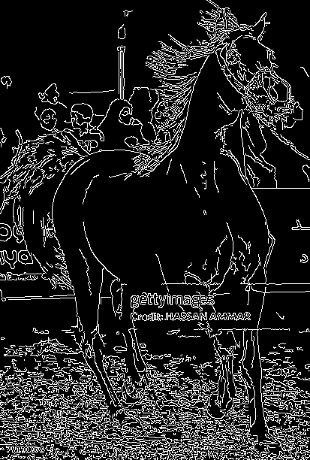
SAMPLE OUTPUT:

RESULT
Thus, the given image was successfully read and its outline/edges were detected using the Canny edge detection function in Python and OpenCV.

